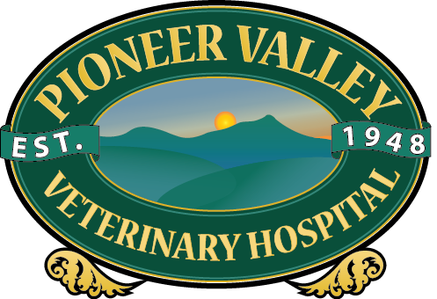
Pioneer Valley Veterinary Hospital
571 Bernardston Road
Greenfield, MA 01301
413-773-7511
www.pvvh.net
Doggie Day Camp Information Sheet
Requirements for day camp:

- DHPP
- Rabies
- Bordetella
- Leptospirosis
- Internal parasite screen every 6 months (Can be performed by PVVH for a fee)*
- Completed camper questionnaire
- All dogs are required to be spayed & neutered by 6 months of age
- Monthly flea and tick prevention is required*

* Any animal found to have internal or external parasites will be treated at the owner’s expense.

All requirements must be completed prior to your camper’s first day of camp and updated as necessary throughout the year. For your convenience you may fax them to us at 413-774-6743 or email them to us at pvvhreceptionist@gmail.com.

If you would like a tour of our facility, we are happy to schedule one with you as times allows. Due to the busy nature of our facility and ongoing activities, we do not do tours at drop off or pick up.

For the safety of all our campers, all dogs’ social skills will be evaluated by one of our camp counselors. All new dogs will be introduced slowly and will be integrated into the supervised play group that best suits them. This is done carefully and at a pace within each dog’s comfort level. Groups are decided based on factors such as size and temperament.

Day camp is meant to be a fun, interactive experience; however we can’t predict every dog’s behavior in every situation. Due to the unpredictable nature of dogs in group play, injuries can occur. Even a vigorous play session can turn into a disagreement resulting in minor injuries. Our camp counselors do everything possible to maintain your camper’s safety. There may be an instance where your dog receives minor injuries; we will inform you of any injuries we are aware of. Please be aware in the instance of an altercation requiring medical attention, you will be responsible for any medical costs incurred. Our hospital staff will attend to your pet and call you with the reason for treatment.

If your camper requires medication during camp, our trained counselors can administer it for an additional fee. If you would like to have your camper to have a meal while at camp you must provide their food and a counselor will make sure they have it. For the safety of our campers and counselors we do not allow raw diets in our camp facility. There is an additional fee for serving a meal to your camper. We are happy to give your camper a treat or two during the day, if you provide them.

Additional services available (Fee applies):

Bath, Nail trim, and Ear Cleaning
Monthly Flea and Tick Application Frontline/Nexgard
Nail Trim Only
Nail Dremmel (grinding)
Internal Parasite Screen (Fecal)
Feed meal (own food must be provided)
Medication Administration

Payment is due prior to being dropped off and prepayment for multiple days is encouraged to speed up drop off and pick up. We do have discounted packages available for multi-day campers. Our Day Camp is closed on weekends and major holidays. (New Year’s Day, Memorial Day, 4th of July, Labor Day, Columbus Day, Veteran’s Day, Thanksgiving and Christmas) If necessary, other times will be posted well in advance.

To insure all campers are given the most interruption free play time for the day, please drop off and pick up during scheduled times. We want all of our campers and counselors to be prepared for the day’s events. Please let us know if you need a special drop off or pick up time. We will try to accommodate you and have additional counselors available so as not to disrupt current camp activities.

Drop Off Hours

Full Day 7:45 AM – 8:15AM
½ Day AM 7:45 AM – 8:15 AM
½ Day PM 12:00 PM – 1:00 PM

Pick Up Hours

½ Day AM 12:00 PM – 1:00 PM
Full Day 4:45 PM – 5:15 PM

